**1. Web Api using .Net core with Swagger**

Program.cs

var builder = WebApplication.CreateBuilder(args);

builder.Services.AddControllers();

builder.Services.AddEndpointsApiExplorer();

builder.Services.AddSwaggerGen(c =>

{

c.SwaggerDoc("v1", new Microsoft.OpenApi.Models.OpenApiInfo

{

Title = "Swagger Demo",

Version = "v1",

Description = "TBD",

TermsOfService = new Uri("https://example.com/terms"),

Contact = new Microsoft.OpenApi.Models.OpenApiContact

{

Name = "John Doe",

Email = "john@xyzmail.com",

Url = new Uri("https://www.example.com")

},

License = new Microsoft.OpenApi.Models.OpenApiLicense

{

Name = "License Terms",

Url = new Uri("https://www.example.com")

}

});

});

var app = builder.Build();

app.UseSwagger();

app.UseSwaggerUI(c =>

{

c.SwaggerEndpoint("/swagger/v1/swagger.json", "Swagger Demo");

});

app.UseAuthorization();

app.MapControllers();

app.Run();

1. Swagger GET Execution Response

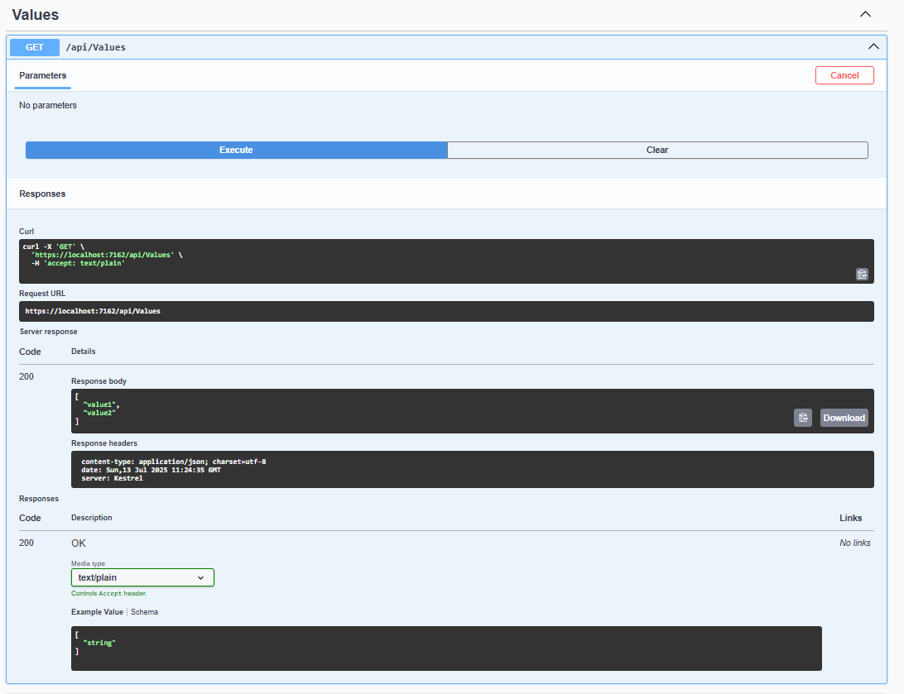

2.Postman GET Request

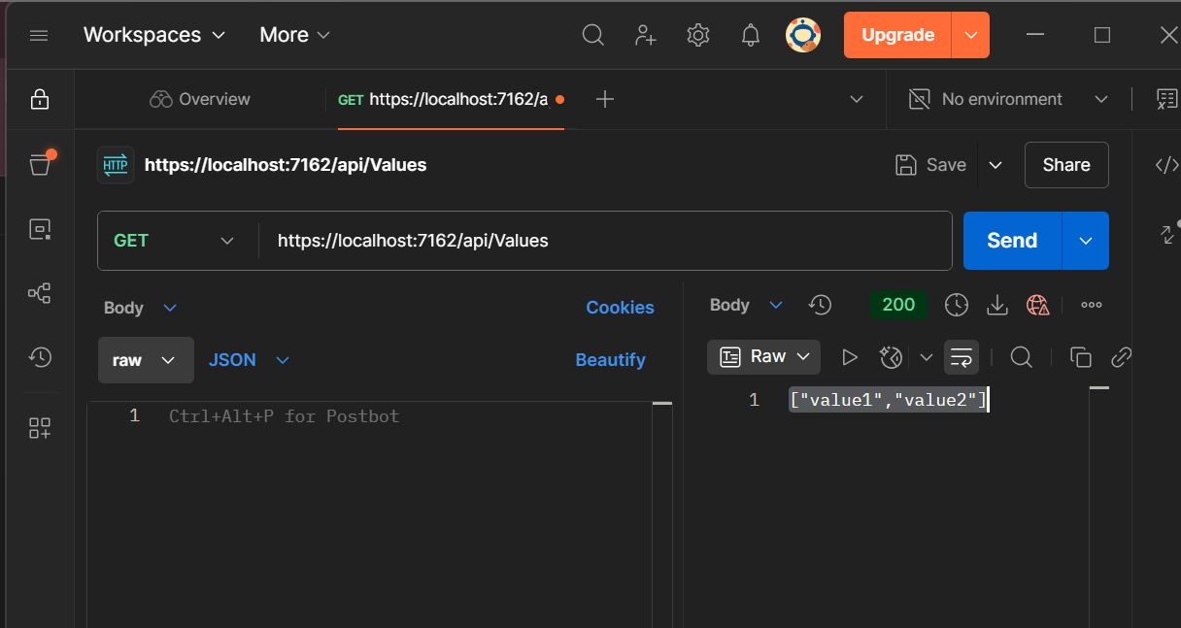

3. Postman POST Request

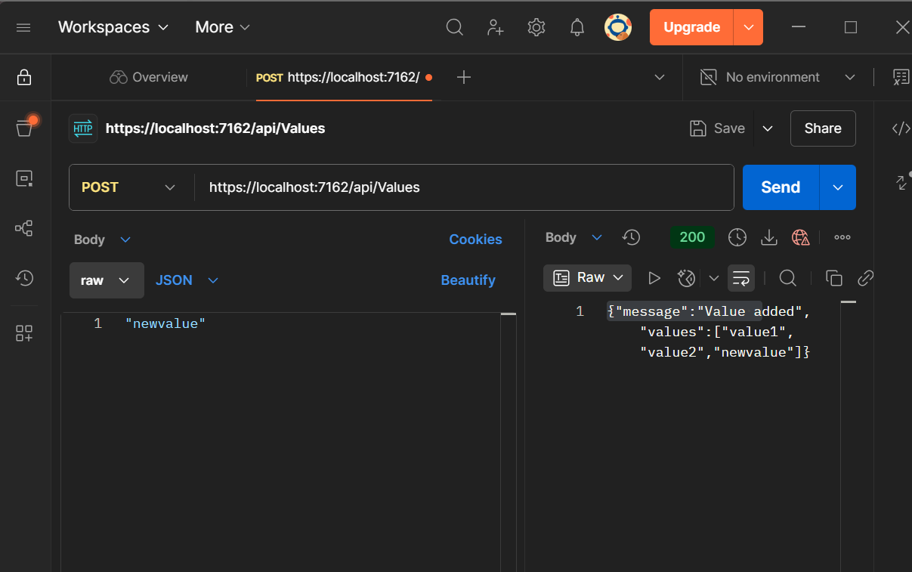

4. Postman GET after Route Change

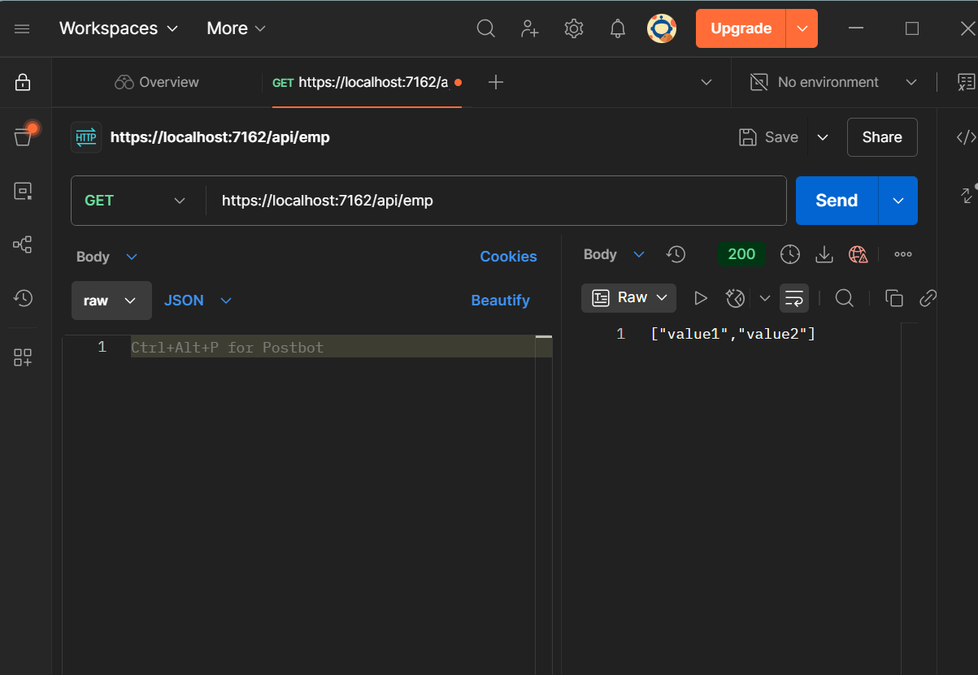

5. Swagger GET Request after Route Change

